Matan Muhamad Isyraf Bin Matan Ibrahim

APIC-EM

Google Map

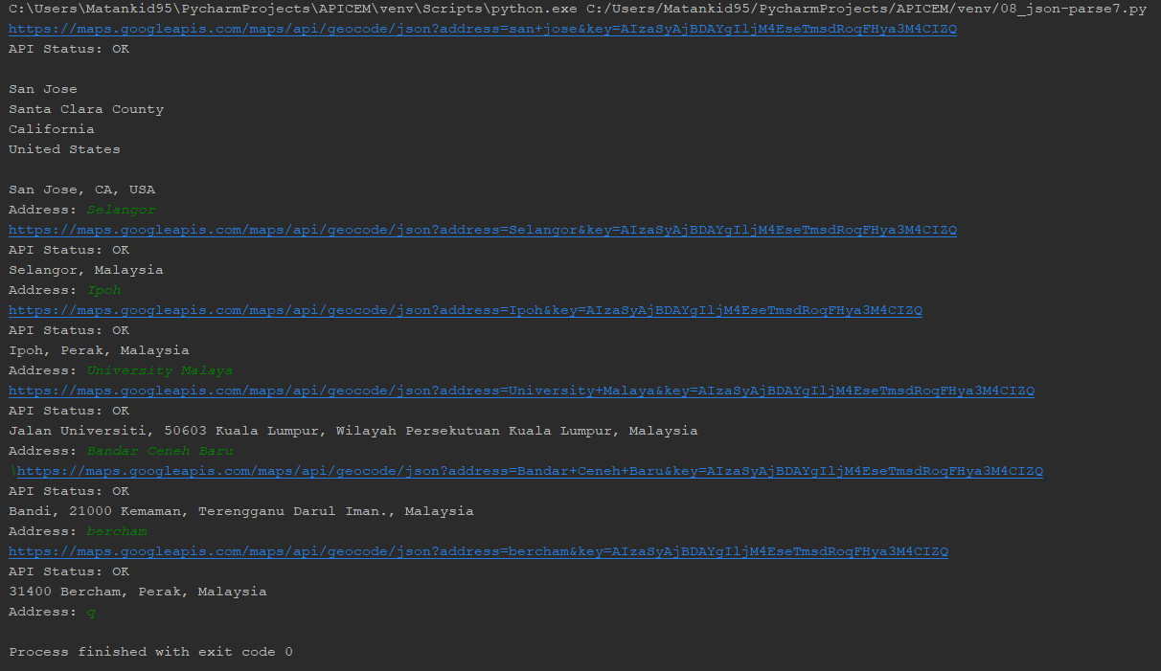

Get_ticket()



04_trace_path

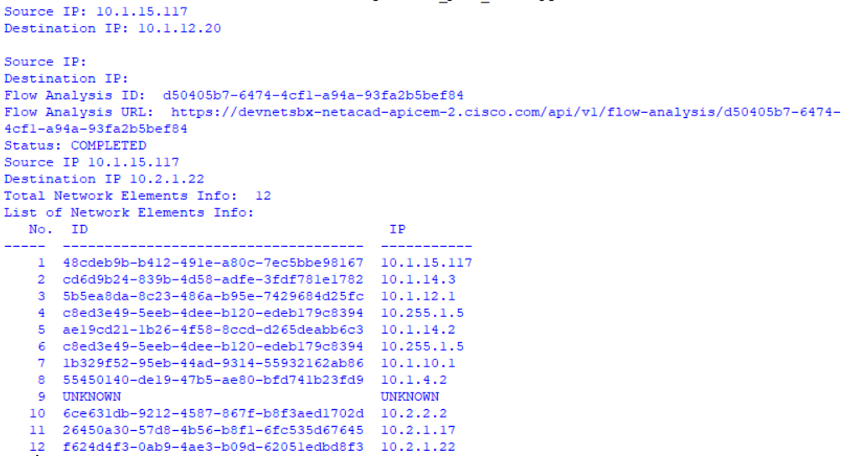

My_apic_function

